Interpersonal Task
Student A:
- You live in Lexington. You have a pen-pal in Beijing. You two talk via Skype every week. You two are interested in the similarities and differences of weather condition between Lexington and Beijing. Here is the weather forecast for Lexington for the next five.
- Tell your penpal the weather for each day in Lexington.
- Then, ask your penpal about the weather in Beijing for next five days. Write down the weather in Beijing in the following form.
- Lastly, ask your penpal his/her plan in the coming weekend. Write down his/her plans.
Lexington, KY, Weather forecast for the next 5 days
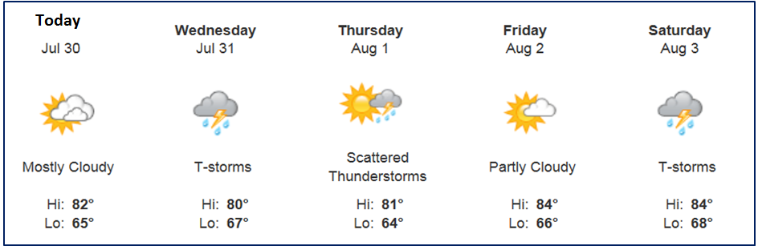http://tianqi.2345.com/beijing/54511.htm
北京的天气
dates
weather

Your penpal’s weekend plan:
___________________________________________________________
___________________________________________________________
Student B:
- You live in Beijing. You have a penpal in Lexington KY. You two talk via Skype every week. You two are interested in the similarities and differences of weather between Lexington and Beijing. Here is the weather forecast for Beijing for the next five days.
- Tell your penpal the weather for each day in Beijing.
- Then, ask your penpal about the weather in Lexington for the next five days. Write down the weather in Lexington in the following form.
- Lastly, ask your penpal his/her plan in the coming weekend. Write down his/her plans.

北京未来五天天气
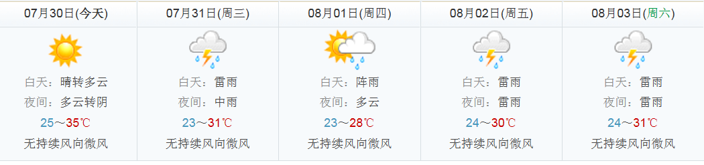
http://local.msn.com/weather.aspx?zip=40508

Lexington的天气
dates
weather

Your penpal’s weekend plan:
___________________________________________________________
___________________________________________________________

